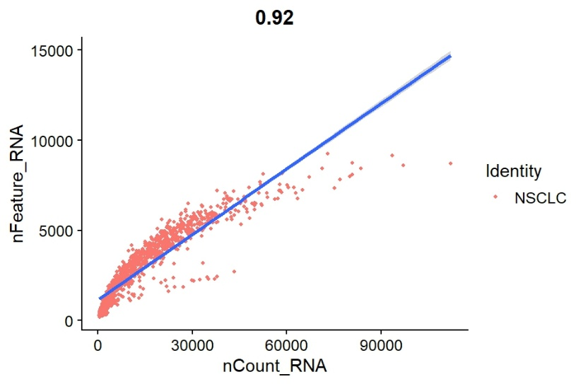
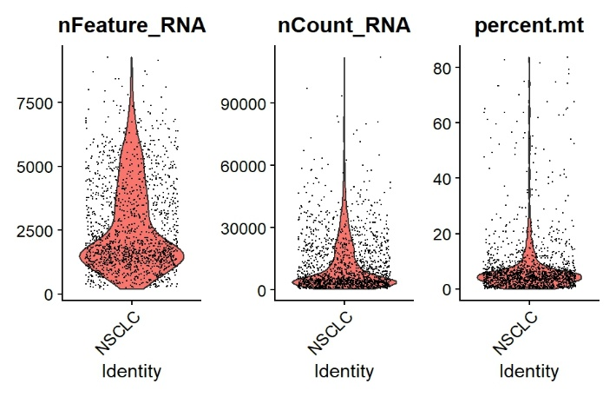
Figure 1. Quality control assessment of single-cell RNA-seq data. Violin plots display the distribution of detected genes (nFeature_RNA), total RNA counts (nCount_RNA), and mitochondrial gene percentage (percent.mt) across cells. A scatter plot illustrates the correlation between nCount_RNA and nFeature_RNA, confirming the relationship between sequencing depth and gene detection. Low-quality cells were removed based on predefined filtering thresholds.

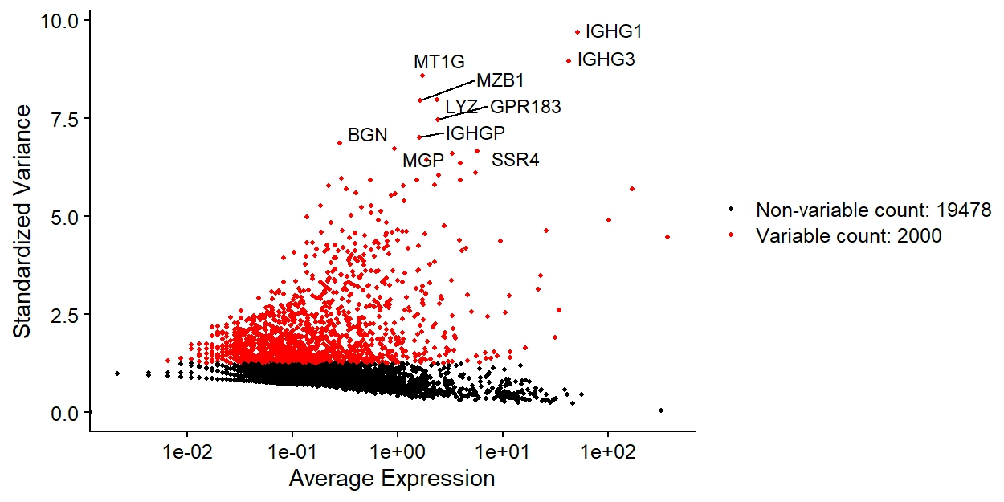
Figure 2 Identification of highly variable genes. VariableFeaturePlot highlighting genes with high cell-to-cell variation used for downstream analysis.

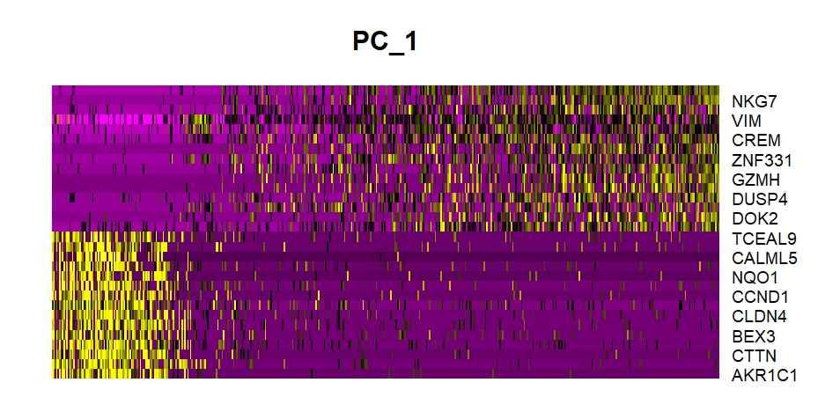
Figure 3 Principal component analysis. PCA heatmap showing genes contributing to the first principal components representing major transcriptional variation.

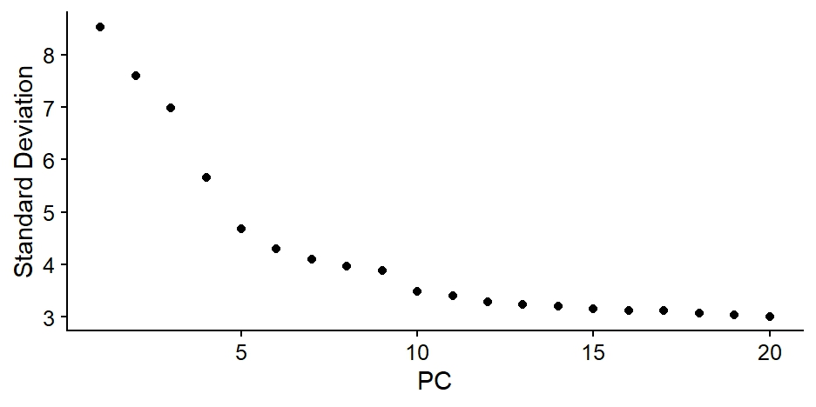
Figure 4 Selection of principal components. ElbowPlot used to determine the optimal number of PCs for clustering and dimensionality reduction.

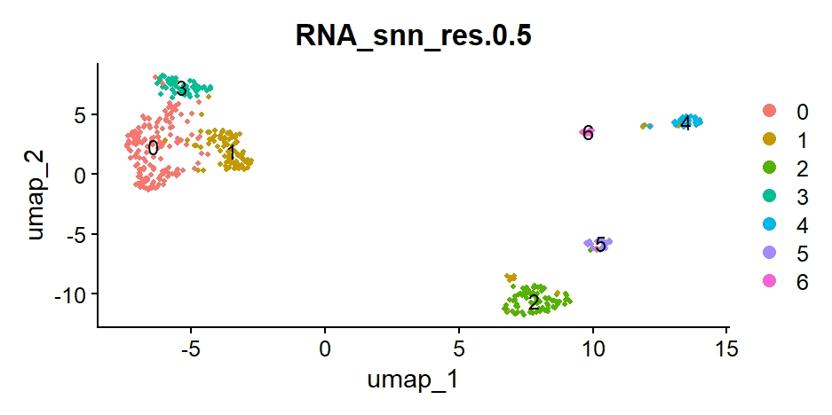
Figure 5 UMAP visualization of cell clusters. UMAP projection of cells based on the first 15 PCs showing transcriptionally distinct clusters in the NSCLC dataset.

